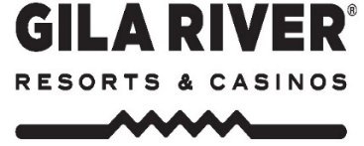
In-House Meeting Request
Complete & return this form to: catering@wingilariver.com

Meeting Name: | Event Date:
Requesting Department: | Start Time:
Requested by. Ext#: | End Time:
Manager or Director Approval:

Meeting Room Requested: | Can you consider any property?: Yes No
External Guests Attending: Yes No | Seating for Guests
AV Requirements: (check all that apply) | Meeting Room Setup: (check all that apply)
Flip Chart | Theater | Rounds
Screen | Conference | Crescent Rounds
Projector | Classroom | Standing Podium
Polycom Speaker Phone | U-Shape | Tabletop Podium
Other: | Hollow Square | Other

Food & Beverage Requirements:

Special Requests:

Budget Transfer # / Billing Arrangements:
Director Signature Approval Required for Internal Meeting Request including F&B & Audio Visual
Director Approval:
PLEASE NOTE:
- All in-house meetings are subject to room changes to accommodate group business or operational needs.
- “Standard In-House Meeting Room Set” includes a Water Station and Glassware.
- No Pens or Papers Provided.
- Your event is not confirmed until the details above are on a Event Order (EO) and signed and returned to Event Services.
- Please submit requests no later than 3 days prior to desired event date. If F&B is desired, requests to be made 7 days prior.

Effective 9/14/18

